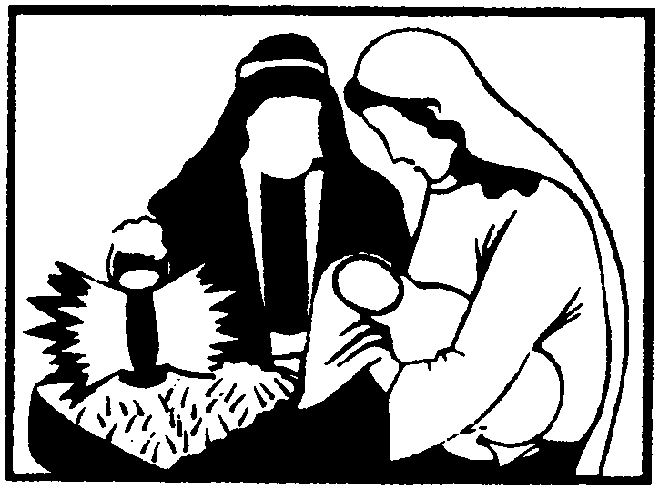 St Andrew's Church

Orford with Longford

**Christmas Morning**

**25th December 2019**

**THE GATHERING**

**Introit hymn:** 62 omit v.5 ‘O come, all ye faithful’

Priest: In the name of the Father and of the Son and of the Holy Spirit. **Amen**

Priest: The Lord be with you.

All: And also with you.

All: Almighty God, to whom all hearts are open, all desires known, and from whom no secrets are hidden: cleanse the thoughts of our hearts by the inspiration of your Holy Spirit, that we may perfectly love you, and worthily magnify your holy name; through Christ our Lord. Amen.

Priest: Hear the words of the angel to Joseph: ‘You shall call his name Jesus, for he will save his people from their sins.’ Therefore, let us seek the forgiveness of God through Jesus the Saviour of the world.

*After a period of silent reflection:*

All: Almighty God, our heavenly Father, we have sinned against you and against our neighbour, in thought and word and deed, through negligence, through weakness, through our own deliberate fault. We are truly sorry and repent of all our sins. For the sake of your Son Jesus Christ, who died for us, forgive us all that is past; and grant that we may serve you in newness of life to the glory of your name. Amen.

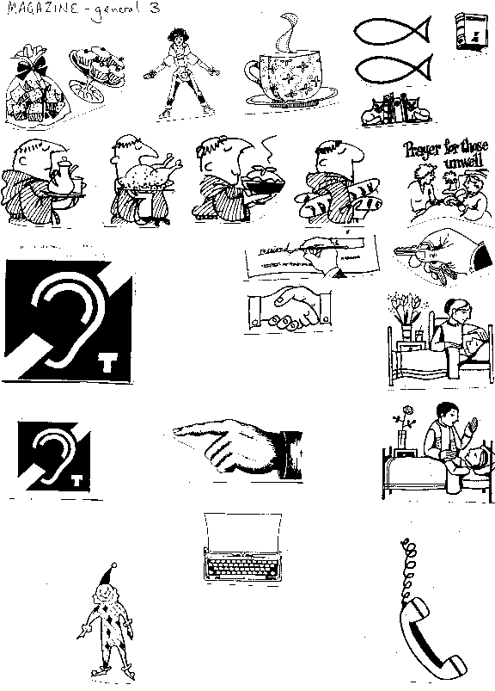Priest: Almighty God, who forgives all who truly repent, have mercy upon you, pardon and deliver you from all your sins, confirm and strengthen you in all goodness, and keep you in life eternal; through Jesus Christ our Lord. **Amen.**

**All: Glory to God in the highest, and peace to his people on earth. Lord**

***(sing)* God, heavenly King, almighty God and Father, we worship you, we give you thanks, we praise you for your glory. Lord Jesus Christ, only Son of the Father, Lord God, Lamb of God, you take away the sin of the world: have mercy on us; you are seated at the right hand of the Father: receive our prayer. For you alone are the Holy One, you alone are the Lord, you alone are the Most High, Jesus Christ, with the Holy Spirit, in the glory of God the Father. Amen.**

**The Collect:** Almighty God, you have given us your only-begotten Son to take our nature upon him and as at this time to be born of a pure virgin: grant that we, who have been born again and made your children by adoption and grace, may daily be renewed by your Holy Spirit; through Jesus Christ your Son our Lord, who is alive and reigns with you, in the unity of the Holy Spirit, one God, now and for ever. **Amen**

#### **THE LITURGY OF THE WORD**

**A reading from the book of the prophet Isaiah** *(Is 9. 2-7)*

The people who walked in darkness have seen a great light; those who lived in a land of deep darkness – on them light has shined. You have multiplied the nation, you have increased its joy; they rejoice before you as with joy at the harvest, as people exult when dividing plunder. For the yoke of their burden, and the bar across their shoulders, the rod of their oppressor, you have broken as on the day of Midian. For all the boots of the tramping warriors and all the garments rolled in blood shall be burned as fuel for the fire. For a child has been born for us, a son given to us; authority rests upon his shoulders; and he is named Wonderful Counsellor, Mighty God, Everlasting Father, Prince of Peace. His authority shall grow continually, and there shall be endless peace for the throne of David and his kingdom. He will establish and uphold it with justice and with righteousness from this time onwards and for evermore. The zeal of the Lord of hosts will do this.

This is the word of the Lord.

All: **Thanks be to God.**

**Gradual hymn:** 68 ‘See him lying on a bed of straw’

##### THE GOSPEL

Priest: The Word became flesh and dwelt among us, and we have seen his glory.

All 🎜 Alleluia, alleluia, alleluia, alleluia. Alleluia, alleluia, alleluia.

Hear the Gospel of our Lord Jesus Christ according to Luke: (*Lk 2. 1-14)*

All 🎜 Glory to you, O Lord

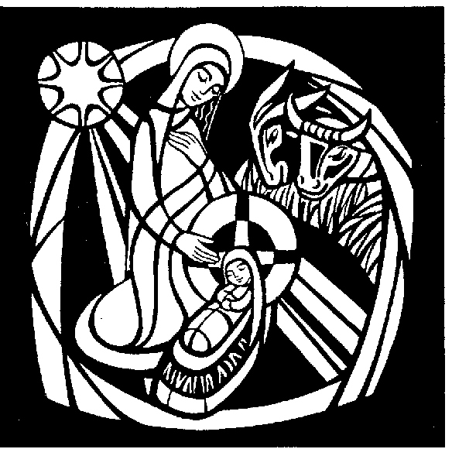In those days a decree went out from Emperor Augustus that all the world should be registered. This was the first registration and was taken while Quirinius was governor of Syria. All went to their own towns to be registered. Joseph also went from the town of Nazareth in Galilee to Judea, to the city of David called Bethlehem, because he was descended from the house and family of David. He went to be registered with Mary, to whom he was engaged and who was expecting a child. While they were there, the time came for her to deliver her child. And she gave birth to her firstborn son and wrapped him in bands of cloth, and laid him in a manger, because there was no place for them in the inn. In that region there were shepherds living in the fields, keeping watch over their flock by night. Then an angel of the Lord stood before them, and the glory of the Lord shone around them, and they were terrified. But the angel said to them, ‘Do not be afraid; for see – I am bringing you good news of great joy for all the people: to you is born this day in the city of David a Saviour, who is the Messiah, the Lord. This will be a sign for you: you will find a child wrapped in bands of cloth and lying in a manger.’ And suddenly there was with the angel a multitude of the heavenly host, praising God and saying, ‘Glory to God in the highest heaven, and on earth peace among those whom he favours!’

This is the Gospel of the Lord

All 🎜 Praise to you, O Christ

**The Sermon**

Please stand to say the Nicene Creed:

Priest: We believe in one God,

**All: the Father, the almighty, maker of heaven and earth, of all that is, seen and unseen.**

We believe in one Lord, Jesus Christ, the only Son of God, eternally begotten of the Father, God from God, Light from Light, true God from true God, begotten, not made, of one Being with the Father; through him all things were made. For us and for our salvation he came down from heaven, was incarnate from the Holy Spirit and the Virgin Mary and was made man. For our sake he was crucified under Pontius Pilate; he suffered death and was buried.

On the third day he rose again in accordance with the Scriptures; he ascended into heaven and is seated at the right hand of the Father. He will come again in glory to judge the living and the dead, and his kingdom will have no end.

We believe in the Holy Spirit, the Lord, the giver of life, who proceeds from the Father and the Son, who with the Father and the Son is worshipped and glorified, who has spoken through the prophets. We believe in one holy catholic and apostolic Church. We acknowledge one baptism for the forgiveness of sins. We look for the resurrection of the dead, and the life of the world to come. Amen.

The Intercession *(please kneel)*

Priest: Let us give glory to God on high for his goodness, and pray for peace and goodwill on earth.

*Each section ends:* Lord, in your mercy.

**All: Hear our prayer.**

**Please remember in your prayers:**

* **those who are ill:**  (4) Mark Shepherd, Marion Greatorex, Eileen Whitehead, Lynn Shaw (3) Vera Wood, Ann Carmen (2) Lynn Burman, Michael Stringer, Michelle Smith, Joyce Hetherington (1) John Hall, Pauline Smith, Alan Ashbrook
* **those who have died:** Carol
* **those whose year's mind falls at this time:** Patrick Hetherington, Stephen Brian Latimer

After the final petition:

Merciful Father,

**accept these prayers**

**for the sake of your Son,**

**our Saviour Jesus Christ. Amen.**

THE LITURGY OF THE SACRAMENT

**The Peace**   *(Please stand)*

Priest: Unto us a child is born, unto us a Son is given: and his name shall be called the Prince of Peace. The peace of the Lord be always with you

All: and also with you

Priest: Let us offer one another a sign of peace.

Everyone is invited to exchange a sign of peace.

**Offertory Hymn:** ‘The Virgin Mary had a baby boy’

The Virgin Mary had a baby boy,

the Virgin Mary had a baby boy,

the Virgin Mary had a baby boy,

and they said that his name was Jesus.

*He came from the glory, he came from the glorious kingdom.*

*He came from the glory, he came from the glorious kingdom.*

*O yes, believer. O yes, believer.*

*He came from the glory, he came from the glorious kingdom.*

The angels sang when the baby was born,

the angels sang when the baby was born,

the angels sang when the baby was born,

and proclaimed him the Saviour Jesus.

The wise men saw where the baby was born,

the wise men saw where the baby was born,

the wise men saw where the baby was born,

and they saw that his name was Jesus.

During the singing of the hymn, a collection is taken, and bread and wine are brought to the altar. The collection is for ‘Room at the Inn’ working with the homeless in Warrington.

Eucharistic Prayer E *(please kneel)*

Priest:The Lord is here.

All 🎜 His Spirit is with us.

Priest:Lift up your hearts.

All 🎜 We lift them to the Lord.

Priest:Let us give thanks to the Lord our God.

All 🎜 It is right to give thanks and praise.

Priest:All glory and honour be yours always and everywhere, mighty creator, ever-living God. We give you thanks and praise for your Son, our Saviour Jesus Christ, who for love of our fallen race humbled himself, was born of the Virgin Mary by the power of your Spirit, and lived as one of us. In this mystery of the Word made flesh you have caused his light to shine in our hearts, to give knowledge of your glory in the face of Jesus Christ. In him we see our God made visible and so are caught up in the love of the God we cannot see. Therefore with all the angels of heaven we lift our voices to proclaim the glory of your name and sing our joyful hymn of praise:

All 🎜 Holy, holy, holy Lord, God of power and might, heaven and earth are

full of your glory. Hosanna in the highest. Blessed is he who comes in the name of the Lord. Hosanna in the highest.

Priest:We praise and bless you, loving Father, through Jesus Christ, our Lord; and as we obey his command, send your Holy Spirit, that broken bread and wine outpoured may be for us the body and blood of your dear Son.

On the night before he died he had supper with his friends and, taking bread, he praised you. He broke the bread, gave it to them and said: Take, eat; this is my body which is given for you; do this in remembrance of me.

When supper was ended he took the cup of wine. Again he praised you, gave it to them and said: Drink this, all of you; this is my blood of the new covenant, which is shed for you and for many for the forgiveness of sins. Do this, as often as you drink it, in remembrance of me.

So, Father, we remember all that Jesus did, in him we plead with confidence his sacrifice made once for all upon the cross. Bringing before you the bread of life and cup of salvation, we proclaim his death and resurrection until he comes in glory.

Great is the mystery of faith:

All 🎜 Christ has died: Christ is risen: Christ will come again.

Lord of all life, help us to work together for that day when your kingdom comes and justice and mercy will be seen in all the earth. Look with favour on your people, gather us in your loving arms and bring us with all the saints to feast at your table in heaven. Through Christ, and with Christ, and in Christ, in the unity of the Holy Spirit, all honour and glory are yours, O loving Father, for ever and ever. **Amen.**

Priest: Rejoicing in the presence of God here among us, let us pray with confidence as our Saviour has taught us:

All: Our Father, who art in heaven, hallowed be thy name; thy kingdom come; thy will be done; on earth as it is in heaven. Give us this day our daily bread. And forgive us our trespasses, as we forgive those who trespass against us. And lead us not into temptation; but deliver us from evil. For thine is the kingdom, the power and the glory, for ever and ever. Amen.

Priest: We break the bread of life, and that life is the light of the world.

**All: God is here among us, light in the midst of us,**

**bring us to light and life**

All 🎜 Lamb of God, you take away the sin of the world, have mercy on us.

Lamb of God, you take away the sin of the world, have mercy on us.

Lamb of God, you take away the sin of the world, grant us peace.

Priest: Jesus is the Lamb of God who takes away the sin of the world.

Blessed are those who are called to his supper.

**All: Lord, I am not worthy to receive you,**

**but only say the word, and I shall be healed.**

Holy Communion is administered at the front of Church. Everyone is warmly invited to receive Holy Communion at this Eucharist. Those who prefer to receive a blessing are also invited to come forward at the same time.

**During Communion:**

Carol: 45 ‘Away in a manger’

68 ‘See amid the winter’s snow’

**After Communion:**

Priest: Let us pray: God our Father, whose Word has come among us in the holy Child of Bethlehem: may the light of faith illumine our hearts and shine in our words and deeds; through him who is Christ the Lord. **Amen**

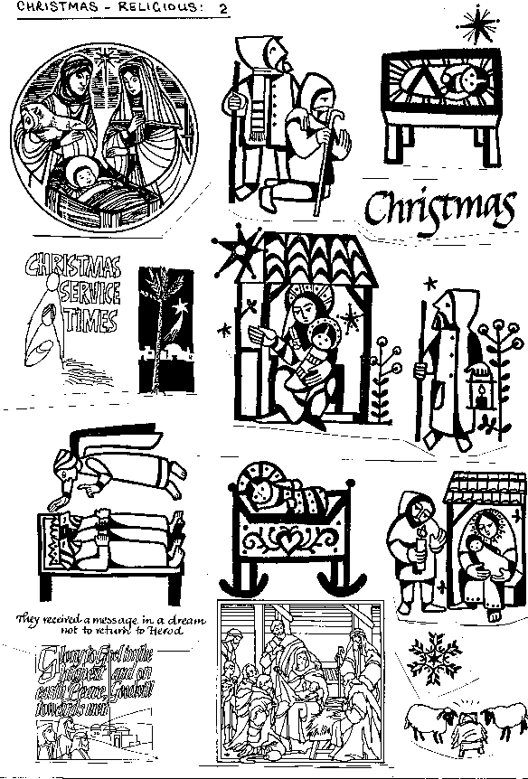All: Almighty God, we thank you for feeding us with the body and blood of your Son, Jesus Christ. Through him we offer you our souls and bodies to be a living sacrifice. Send us out in the power of your Spirit to live and work to your praise and glory. Amen.

Priest: Christ, who by his incarnation gathered into one all things earthly and heavenly, fill you with peace and goodwill and make you partakers of the divine nature; and the blessing of God almighty, the Father, the Son, and the Holy Spirit, be among you, and remain with you always. **Amen**

**Recessional hymn:**

57 ‘Joy to the world’

**THE DISMISSAL**

Priest: Go in joy and peace

to love and serve the Lord.

All: In the name of Christ. Amen

❄ ❄ ❄ ❄ ❄ ❄ ❄ ❄ ❄ ❄ ❄ ❄ ❄ ❄ ❄ ❄ ❄ ❄ ❄ ❄ ❄ ❄ ❄ ❄

**Services this week:**

**Thursday 26th St Stephen, the First Martyr - 10.30am Eucharist**

**Friday 27th St John Evangelist – 10.30am Eucharist**

**Sunday 29th The First Sunday of Christmas**

**10.00am Sung Eucharist**



**Christmas Morning 25th December 2019**

Priest: Let us pray for the Church and the world, and let us thank God for his goodness.

(when all are kneeling)

Leader: To us a child is born,

to us a Son is given.

Wonderful Counsellor,

give your wisdom to the rulers of the nations.

Lord, in your mercy

**All:** **hear our prayer**

Leader: Mighty God,

make the whole world know

that the government is on your shoulders.

Lord, in your mercy

**All:** **hear our prayer**

Leader: Everlasting Father,

establish your reign of justice and righteousness.

Lord, in your mercy

**All:** **hear our prayer**

Leader: Prince of Peace,

bring in the endless kingdom of your peace.

Lord, in your mercy

**All:** **hear our prayer**

Leader: Loving Lord,

be with those who are sick at this time, including

Lynn Shaw, Ann Carmen, Joyce Hetherington, John Hall and Alan Ashbrook; and any known to us personally.

Lord, in your mercy

**All:** **hear our prayer**

Leader: Risen Saviour,

who brought us the hope of eternal life,

hear our prayers for those who have died recently.

Hear us as we remember those dear to us ...

for Carol who died recently

and those whose anniversary of death falls at this time,

and especially Patrick Hetherington and Stephen Lafferty.

Leader: Rejoicing in the fellowship of the Blessed Virgin Mary, St Joseph and all your saints, we commend ourselves and all Christian people to your unfailing love.

Merciful Father,

**All: accept these prayers,**

**for the sake of your Son,**

**our Saviour Jesus Christ. Amen**

# 

# Christmas morning 25th December 2019

**A reading from the book of the prophet Isaiah**

The people who walked in darkness have seen a great light; those who lived in a land of deep darkness – on them light has shined. You have multiplied the nation, you have increased its joy; they rejoice before you as with joy at the harvest, as people exult when dividing plunder. For the yoke of their burden, and the bar across their shoulders, the rod of their oppressor, you have broken as on the day of Midian. For all the boots of the tramping warriors and all the garments rolled in blood shall be burned as fuel for the fire. For a child has been born for us, a son given to us; authority rests upon his shoulders; and he is named Wonderful Counsellor, Mighty God, Everlasting Father, Prince of Peace. His authority shall grow continually, and there shall be endless peace for the throne of David and his kingdom. He will establish and uphold it with justice and with righteousness from this time onwards and for evermore. The zeal of the Lord of hosts will do this.

This is the word of the Lord.

**All: Thanks be to God.**

***NB There is only one reading this morning.***